AMIT PATIDAR
244CA004

QUERIES FOR CLASSROOM

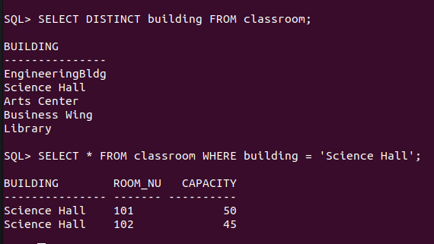
QUERIES FOR DEPARTMENT

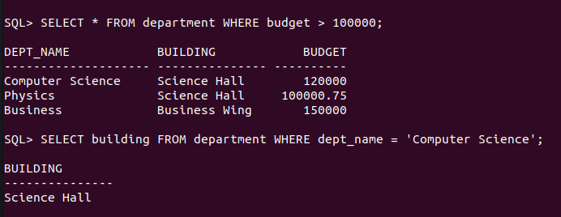

QUERIES FOR COURSE
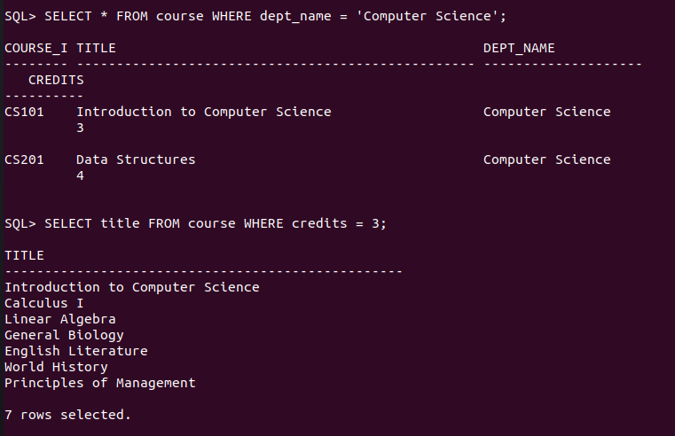
QUERIES FOR INSTRUCTOR
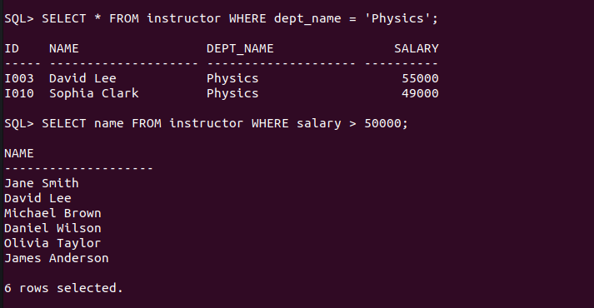

QUERIES FOR STUDENT

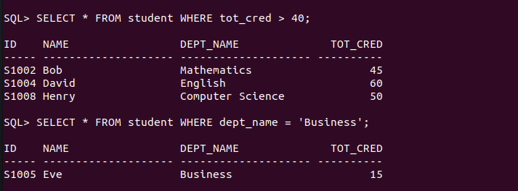

QUERIES FOR SECTION

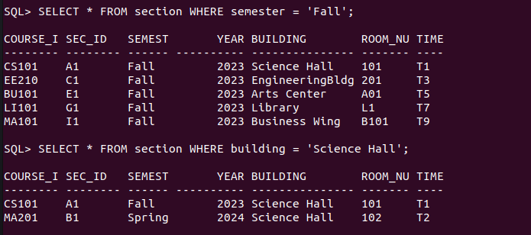

QUERIES FOR TEACHES

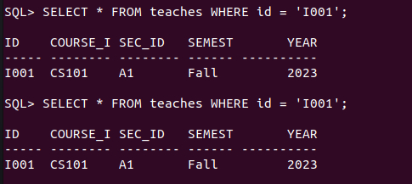

QUERIES FOR TAKES
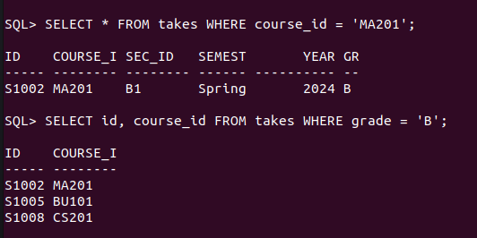

QUERIES FOR ADVISOR\

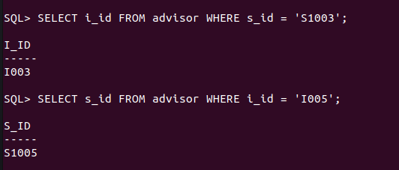

QUERIES FOR TIME_SLOT
